



Business Requirement Document
Finance
NWS Petty Cash System
DOCUMENT FOR

Table of Contents:
Table of Contents: 1
1. Introduction 3
1.1 Business Need 3
1.2 Expected Business Outcomes 3
1.3 Project Scope Summary 3
2. Business Requirement Details 3
2.1 Requirement Description 3
2.2 Functional Requirements 4
2.3 Non-Functional Requirements 4
3. System Integration 4
4. Process Flow 5
5. Application Prototype 6
6. Open and Close Issues 8
6.1 Open Issues 8
6.2 Closed Issues 8

Document Control

Date | Author | Version | Change Reference
19-Oct-2025 | Mr. Vignesh Subramani | 1.0 | No Previous Version
Change Record

Reviewers
Name | Position
Mr. Parthasarathy | Project Manager, 4iapps, Oman

Approver
Name | Position | Signature
Mrs. Shaima Ibrahim Abbas Al Hooti | Investment Relationship Head

Note to Holders:
If you receive an electronic copy of this document and print it out, please write your name on the equivalent of the cover page, for document control purposes.
If you receive a hard copy of this document, please write your name on the front cover, for document control purposes.

Introduction

1.1 Business Need
Nama Water Services currently operates the Petty Cash System in Custom OAF Page. Petty Cash System is used to capture petty cash expenses related to department for each region.

1.2 Expected Business Outcomes
- Create Petty Cash expenses claim for each region with the invoice attachment. For each region the approval hierarchy is different.

1.3 Project Scope Summary
The scope of this Application covers:
- Custom development of Petty Cash Expenses Claim creation page.
- Approval workflow for each petty cash claim.
- Transaction Creation and interfaced to General Ledger and Payables.

2. Business Requirement Details

2.1 Requirement Description
Petty Cash end users will create the petty cash expense claim for each region.
Supplier Details: For each region we have different suppliers.
Bank Details: Used to capture the bank information for the Petty cash user. Once petty cash expense claim is created and approved it will be interfaced to payables module.

2.2 Functional Requirements
Functional Requirement | Detailed Description
Petty Cash Expense Claim Page | End users will create the petty cash expense claim related to the region assigned to their login.
AP Invoice | AP Invoice will be created once the petty cash claim is approved.

2.3 Non-Functional Requirements
- System should support 100% availability.
- Page load response time under 3 seconds.
- Complete audit trail for every action and system integration log.

3. System Integration
System | Module | Integration Point
Oracle Fusion | Accounts Payable | Automatic AP Invoice creation in Oracle Fusion upon successful approved transaction from Petty Cash system.

4. Process Flow

5. Application Prototype
Petty Cash Expenses Claim Creation Page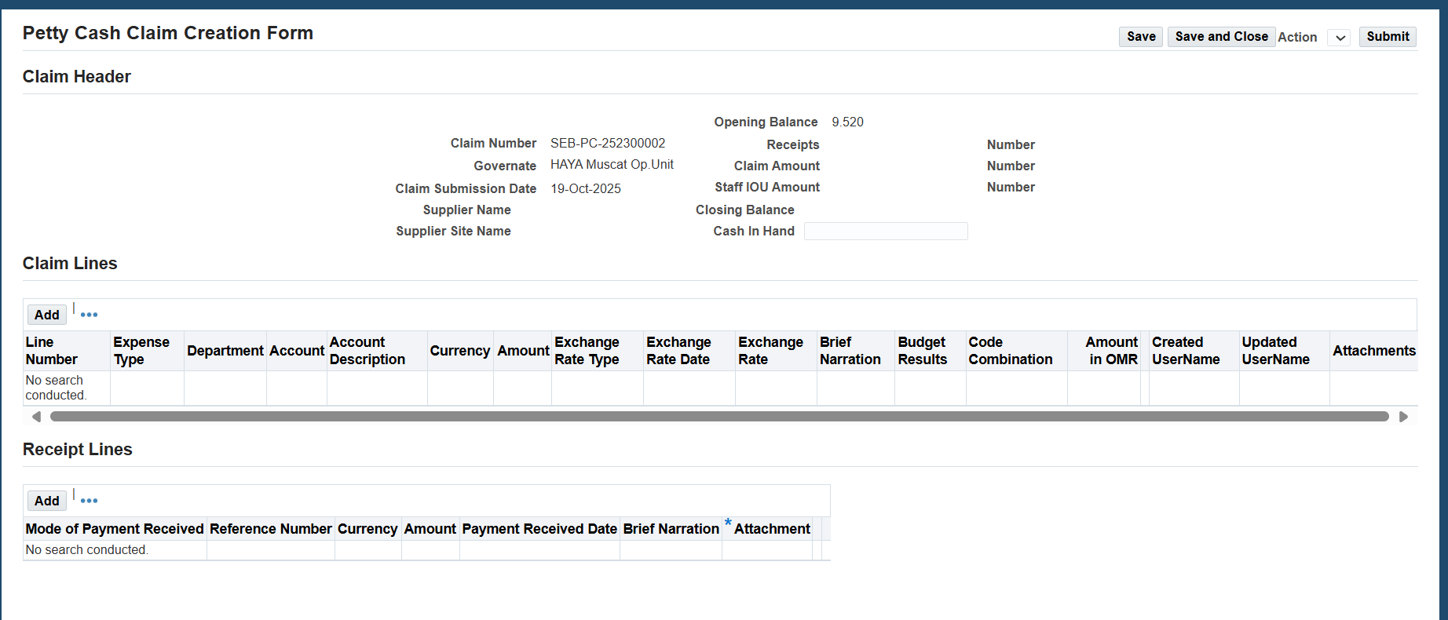
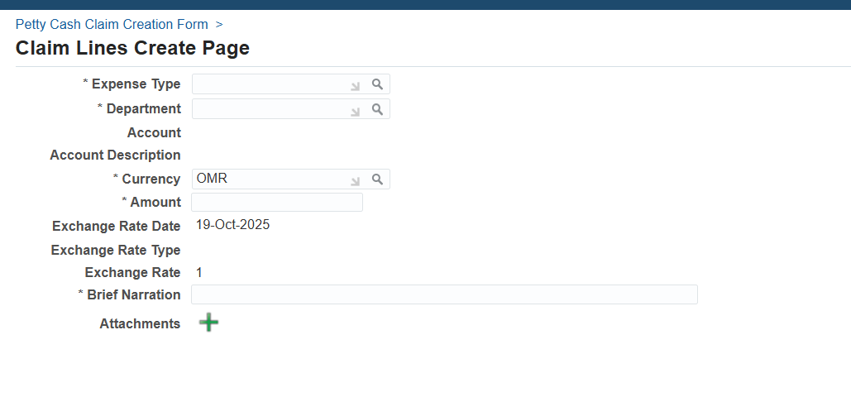

6. Open and Close Issues

6.1 Open Issues
S. No | Issue | Resolution | Responsibility | Target Date | Impact Date
1
2

6.2 Closed Issues
S. No | Issue | Resolution | Responsibility | Target Date | Impact Date
1
2

